Font -
oxygen

Color -
- Background colour (replace to the image we use now)
- #404041

- Selected countries
- #ed1c24
- #f15a29
- #fff100
- #94e01b
- #4dd5ff
- #1e29f7
- #0e0e51
- #763cd3
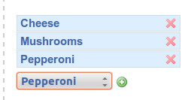
- #631f4c
- #ec008b

- Selector list
- #58595b

- Color for map (i think grey is fine, and here is the codes, from lightest to darkest)
- #d1d3d4
- #a7a9ac
- #808285
- #6d6e71
- #58595b

